**Computer Vision**

3D Object Detection

Supervise by :

Dr. Marwan Torki

Eng. Aya Lotfy

Prepared by:

Moustafa Tohamy 3851

Ziad Ezzat 4492

Moustafa Sherif Ahmed 4347

# **Outline:**

* Kitti 3d object detection BenchMark
* Frustum ConvNet: Sliding Frustums to Aggregate Local Point-WiseFeatures for Amodal 3D Object Detection
* Stereo R-CNN based 3D Object Detection for Autonomous Driving
* Our results

# 

# **KITTI’s 3D Object Detection Benchmark**

Andreas Geiger Philip Lenz Raquel Urtasun

Karlsruhe Institute of Technology

Toyota Technological Institute at Chicago

<https://www.cvlibs.net>

<https://davidstutz.de/kittis-3d-object-detection-benchmark/>

<http://www.cvlibs.net/datasets/kitti/eval_object.php?obj_benchmark=3d>.

<https://www.kaggle.com/twaldo/kitti-object-detection>

* The 3D object detection benchmark consists of 7481 training images ,7518 test and the corresponding point clouds with a total of 80.256 labeled objects.
* precision-recall curves is computed for evaluation.
  + Train data
    - Left Colored Images 12 GB
    - Right Colored Images 12 GB
    - Velodyne point clouds( laser information) 29 GB
      * X/Z plane (bird's eye view)
    - camera calibration matrices 25 MB
    - training labels 5 MB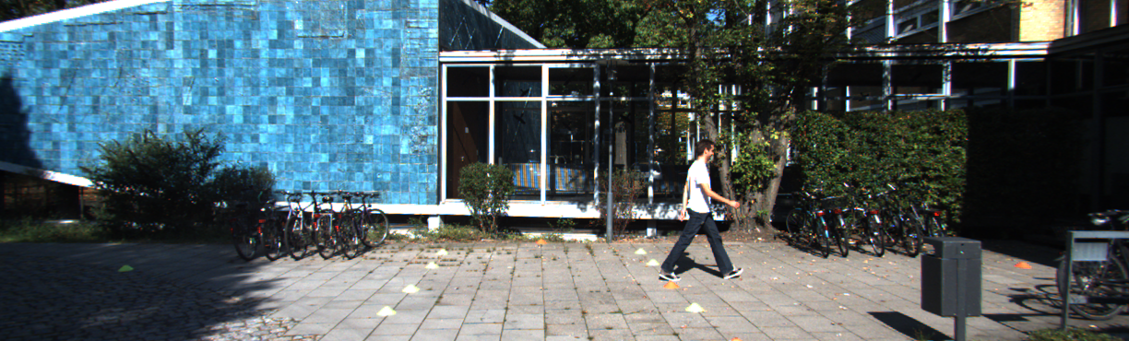

Left Image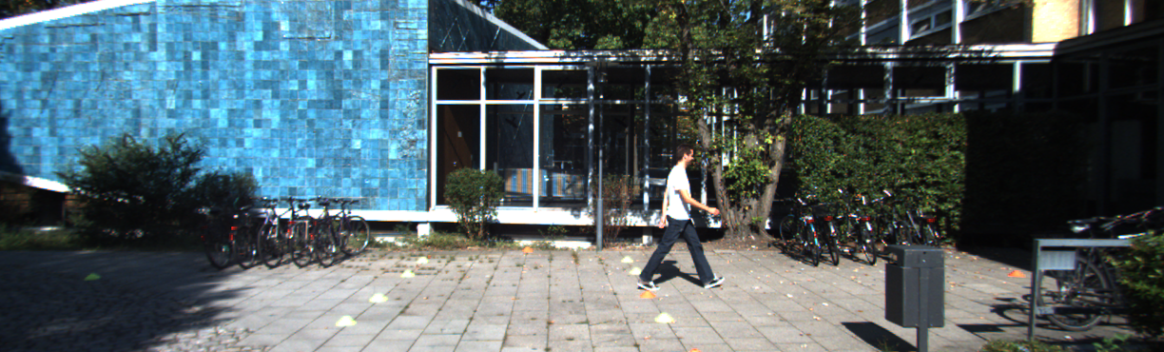

Right image

* **Camera: x = right, y = down, z = forward;**
* **Velodyne: x = forward, y = left, z = up.**

**Calibration**

P0: 7.070493000000e+02 0.000000000000e+00 6.040814000000e+02 0.000000000000e+00 0.000000000000e+00 7.070493000000e+02 1.805066000000e+02 0.000000000000e+00 0.000000000000e+00 0.000000000000e+00 1.000000000000e+00 0.000000000000e+00

P1: 7.070493000000e+02 0.000000000000e+00 6.040814000000e+02 -3.797842000000e+02 0.000000000000e+00 7.070493000000e+02 1.805066000000e+02 0.000000000000e+00 0.000000000000e+00 0.000000000000e+00 1.000000000000e+00 0.000000000000e+00

P2: 7.070493000000e+02 0.000000000000e+00 6.040814000000e+02 4.575831000000e+01 0.000000000000e+00 7.070493000000e+02 1.805066000000e+02 -3.454157000000e-01 0.000000000000e+00 0.000000000000e+00 1.000000000000e+00 4.981016000000e-03

P3: 7.070493000000e+02 0.000000000000e+00 6.040814000000e+02 -3.341081000000e+02 0.000000000000e+00 7.070493000000e+02 1.805066000000e+02 2.330660000000e+00 0.000000000000e+00 0.000000000000e+00 1.000000000000e+00 3.201153000000e-03

R0_rect: 9.999128000000e-01 1.009263000000e-02 -8.511932000000e-03 -1.012729000000e-02 9.999406000000e-01 -4.037671000000e-03 8.470675000000e-03 4.123522000000e-03 9.999556000000e-01

Tr_velo_to_cam: 6.927964000000e-03 -9.999722000000e-01 -2.757829000000e-03 -2.457729000000e-02 -1.162982000000e-03 2.749836000000e-03 -9.999955000000e-01 -6.127237000000e-02 9.999753000000e-01 6.931141000000e-03 -1.143899000000e-03 -3.321029000000e-01

Tr_imu_to_velo: 9.999976000000e-01 7.553071000000e-04 -2.035826000000e-03 -8.086759000000e-01 -7.854027000000e-04 9.998898000000e-01 -1.482298000000e-02 3.195559000000e-01 2.024406000000e-03 1.482454000000e-02 9.998881000000e-01 -7.997231000000e-01

*To project a point from Velodyne coordinates into the left color image, you can use this formula: x = P2 * R0_rect * Tr_velo_to_cam * y For the right color image: x = P3 * R0_rect * Tr_velo_to_cam * y*

**Training file**

Pedestrian 0.00 0 -0.20 712.40 143.00 810.73 307.92 1.89 0.48 1.20 1.84 1.47 8.41 0.01

**Training Labels**

* + 1 type -> 'Car', 'Van', 'Truck', 'Pedestrian', 'Person_sitting', 'Cyclist', 'Tram', 'Misc' or 'Don't Care' “too far away from the laser scanner. won’t be counted as false positives”
  + 1 truncated Float from 0 (non-truncated) to 1 (truncated) object leaving image boundaries
  + 1 occluded Integer (0,1,2,3) indicating occlusion state: 0 = fully visible, 1 = partly occluded 2 = largely occluded, 3 = unknown
  + 1 alpha Observation angle of object, ranging [-pi..pi]
  + 4 bbox 2D bounding box of an object in the image (0-based index): contains left, top, right, bottom pixel coordinates 3 dimensions 3D object dimensions: height, width, length (in meters)
  + 3 location 3D object location x,y,z in camera coordinates (in meters) 1 rotation_y Rotation ry around Y-axis in camera coordinates [-pi..pi]
  + 1 score Only for results: Float, indicating confidence in
* **Evaluation**
  + The goal in the 3D object detection task is to **train object detectors** for the classes 'Car', 'Pedestrian', and 'Cyclist'.
  + The object detectors must provide BOTH the
    - * 2D 0-based bounding box in the image
      * 3D bounding box (3D dimensions and 3D locations)
      * detection score/confidence.
    - Note that the 2D bounding box should correspond to the projection of the 3D bounding box - this is required to filter objects larger than 25 pixel (height).
    - Similar to the 2D object detection benchmark, we do not count 'Van' as false positives for 'Car' or 'Sitting Person' as false positive for 'Pedestrian'.
    - Evaluation criterion follows the 2D object detection benchmark (using 3D bounding box overlap).
    - For **cars** we require an 3D bounding box **overlap of 70%**,
    - For **pedestrians** ,**cyclists** we require a 3D bounding box **overlap of 50%**.
    - Difficulties are defined as follows:
      * **Easy:** Min. bounding box height: 40 Px, Max. occlusion level: Fully visible, Max. truncation: 15 %
      * **Moderate:** Min. bounding box height: 25 Px, Max. occlusion level: Partly occluded, Max. truncation: 30 %
      * **Hard:** Min. bounding box height: 25 Px, Max. occlusion level: Difficult to see, Max. truncation: 50 %

# **Frustum ConvNet: Sliding Frustums to Aggregate Local Point-WiseFeatures for Amodal 3D Object Detection**

arXiv:1903.01864v2 [cs.CV] 14 Aug 2019

<https://arxiv.org/pdf/1903.01864.pdf>

* **Introduction :**
  + Frustum ConvNet (F-ConvNet)for amodal 3D object detection from point clouds. Given 2D region proposals in an RGB image, first generates a sequence of frustums for each region proposal, and uses the obtained frustums to group localpoints.
  + F-ConvNet aggregates point wise features as frustum level feature vectors, and arrays these feature vectors as a feature map for use of its subsequent component of fully convolutional network (FCN), which spatially fuses frustum level features and supports an end-to-end and continuous estimation of oriented boxes in the 3D space.
  + it also propose component variants of F-ConvNet, including an FCN variant that extracts multi-resolution frustum features, and a refined use of F-ConvNet over a reduced 3D space. Careful ablation studies verify the efficacy of these component variants.
  + F-ConvNet assumes no prior knowledge of the working 3D environment and is thus dataset agnostic. It presents experiments on both the indoor SUN-RGBD and outdoor KITTI datasets.
* **Related Work**
  + Methods based on data conversion
    - Project Lidar point clouds to bird eye view then employs faster R-CNN
    - Some existing methods also use depth images as converted data of point clouds ,directly estimate 3d objects based on fast R-CNN pipeline
    - Conversion from 3d to 2d losses a lot of important information
  + Methods working on raw cloud points
    - F-PointNet :starts with an instance segmentation then T-Net alignment ,It’s not and end to end pipeline
    - Voxel Net: Divide the Point clouds into equal voxels then start the detection process, but needs to know the voxel shape
* **Proposed Frustum ConvNet**
  + F-ConvNet supports end-to-end learning 3d object detection,in the 3D space, that is determined by 2D region proposals.
  + grouping mechanism – sliding frustums was used to aggregate local pointwise features for use of a subsequent FCN.
  + They propose component variants of F-ConvNet, including an FCN variant that extracts multi-resolution frustum features, and a refined use of F-ConvNet over a reduced 3D space.
  + Careful ablation studies verify the efficacy of these components and variants.
  + F-ConvNet assumes no prior knowledge of the working 3D environment, and is thus dataset agnostic.
  + On the in-door SUN-RGBD dataset , F-ConvNet outperforms all existing methods; on the outdoor dataset of KITTIbenchmark , it outperforms all published works at the time of submission.  
      
    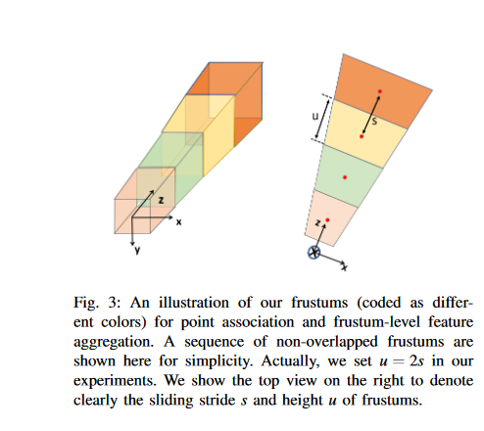
* **Associate Point Clouds With Sliding Frustum**
  + Assuming
    - RGB images is available
    - 2D Region Proposal available by object detectors
    - optical axis of the camera is perpendicular to this 2D region
    - Point clouds available
  + A sequence of (possibly overlapping) frustums can be obtained by sliding a pair of parallel planes along the frustum axis with an equal stride, where the pair of planes are also perpendicular to the frustum axis.
  + for each 2D region proposal a sequence of frustums whose feature vectors are arrayed as a feature map and used in a subsequent FCN for an end-to-end estimation of oriented boxes in the continuous 3D space  
      
      
      
      
      
      
      
    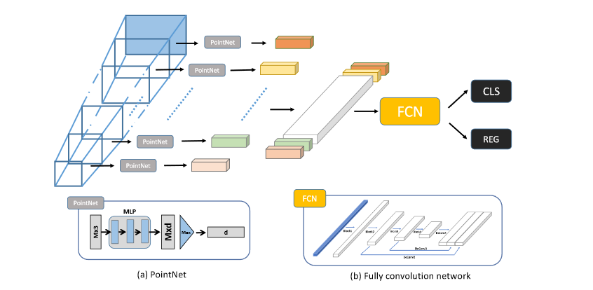
* **The Architecture of Frustum Convnet**
  + Each frustum used as an input to PointNet with shared weights (a in the figure)
  + All PointNet outputs get concatenated as 2d feature representation of this area
  + Concatenated feature map used as an input to to fully convolution layer (FCN)(b in the figure)
  + The output of FCN used as input to two parallel networks
    - Classification for each category
    - Regression for 3d bounding box
* **Feature Level extraction**
  + First part of the architecture is responsible of extraction the
* **Multi Resolution Frustum Feature integration variant**
  + Applying different frustum with different height and stride will be a problem because you will have a different number of frustums each time
  + This problem is solved by applying different height and scales with some factor ,for example suppose you have l* d feature map after stacking all of the outputs of PointNet when you apply stride =s and height = h , so if we apply stride = 2s ,height =h ,we will get l/2 *d feature map and if we apply stride=s, height = 2h, stride =s we will also get l/2*d feature map , we can merge both of them to get l*d feature map and use the usual pipeline
  + 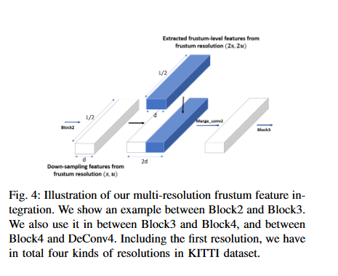
* Detection of Headers and Training of Network
  + After the above explained architecture , there is an extra 2 networks
  + Regression Network to get the bounding box place (x,y,z,l,w,h,theta)
    - (x,y,z) coordinates of box centre
    - (l,w,h) three lengths sides of the box
    - theta is the angle of the box
  + Classification Network for each class , suppose we have K classes, size of output is L , so the output will be of size (K+1 x L) , extra one for the background
* **Final Refinement**
  + This an extra step to increase the accuracy
  + Due to incorrect estimation of 2d Region Proposals , the 3d location is not that accurate
  + So applying the same Network for the region we get as output from the network before
    - Expand the region by some factor (1.2 used)
    - Normalize the point inside the expanded box by translation and rotation as in the figure below
    - Use the new regions as input to the same F-ConvNet

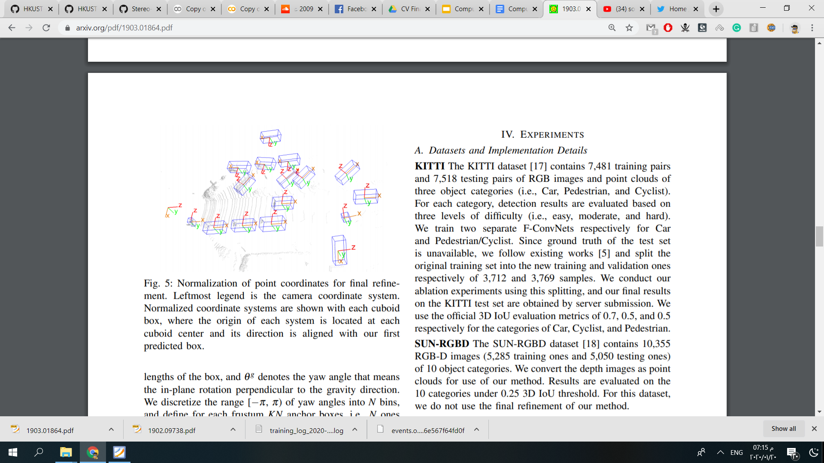

* **Detailed Description of the fully Convolution Layer**  
    
  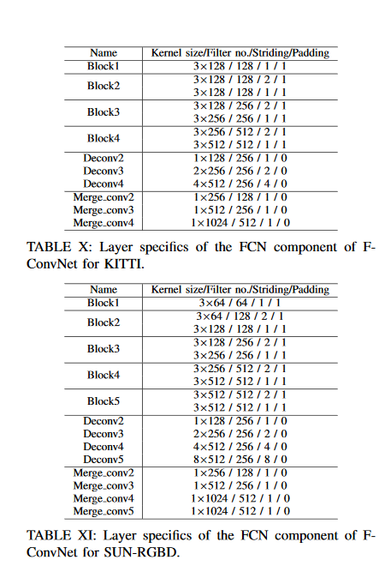
* **Results**
  + Now on bench mark ranked as
    - 31 in car category
    - 6 in padestarian
    - 2 in cyclists

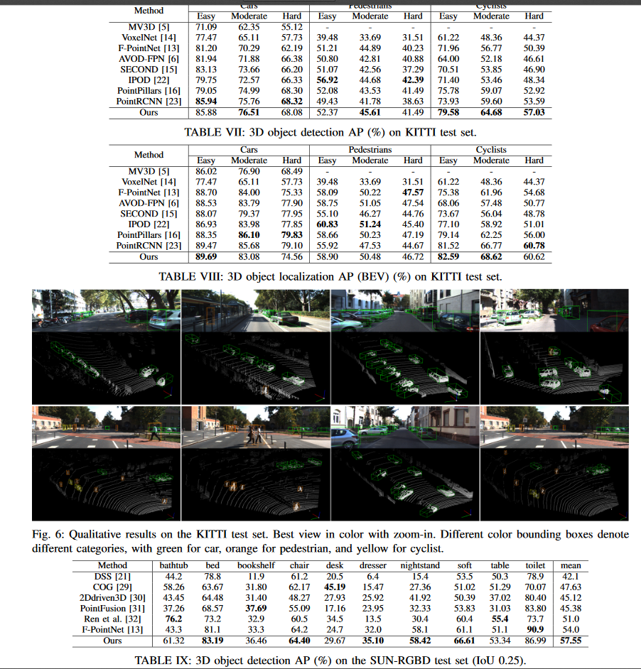

# **Stereo R-CNN based 3D Object Detection for Autonomous Driving**

Peiliang Li, Xiaozhi Chen2, Shaojie Shen

The Hong Kong University of Science and Technology,DJI

pliap@connect.ust.hk, cxz.thu@gmail.com, [eeshaojie@ust.hk](mailto:eeshaojie@ust.hk)

<https://arxiv.org/pdf/1902.09738.pdf>

<https://github.com/HKUST-Aerial-Robotics/Stereo-RCNN>

**1-Introduction**

-3D object detection serves as an essential basis of visual perception, motion prediction, and planning for autonomous driving. Currently, most of the 3D object detection methods heavily rely on **LiDAR** data for providing accurate depth information in autonomous driving scenarios. However, LiDAR has the disadvantage of **high cost**.On the other hand, **monocular camera** provides alternative low-cost solutions for 3D object detection. The depth information can be predicted by semantic properties in scenes and object size, etc. However, the inferred depth **cannot guarantee the accuracy**, especially for unseen scenes. To this end, they propose a **stereo-vision based 3D** object detection method.

-Comparing with monocular camera, stereo camera provides more precise depth information by **left-right photometric alignment**. Comparing with Li- DAR, stereo camera is low-cost while achieving comparable depth accuracy for objects with non-trivial disparities.

-This method simultaneously detects and associates objects for left and right images using the proposed Stereo R-CNN. The network architecture can be overviewed in Fig.1 which can be divided into three main parts. The first one is a Stereo RPN (Region Proposal Network) module which outputs corresponding left and right RoI proposals. After applying RoIAlign on left and right feature maps respectively, we concatenate left-right RoI features to classify object categories and regress accurate 2D stereo boxes, viewpoint, and dimensions in the stereo regression branch. A keypoint branch is employed to predict object keypoints using only left RoI feature. These outputs form the sparse constraints (2D boxes, keypoints) for the 3D box estimation ,where we formulate the projection relations between 3D box corners with 2D left-right boxes and keypoints. The crucial component that ensures our 3D localization performance is the dense 3D box alignment

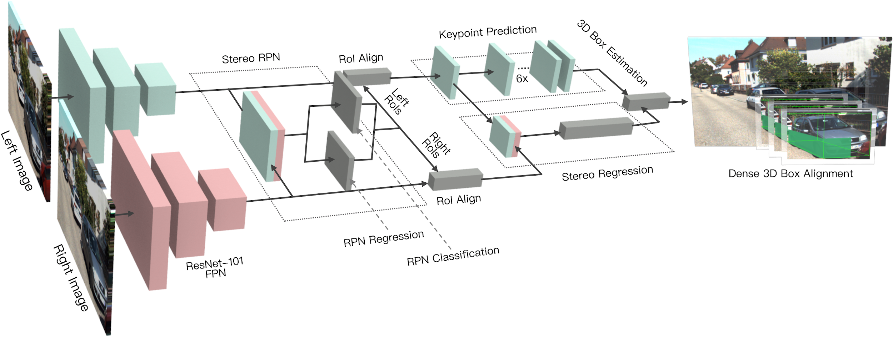

Figure 1. Network architecture of the proposed Stereo R-CNN which outputs stereo boxes, keypoints, dimensions, and the viewpoint angle, followed by the 3D box estimation and the dense 3D box alignment module.

They summarize the main contributions as follows:

* A Stereo R-CNN approach which simultaneously detects and associates object in stereo images.
* A 3D box estimator which exploits the keypoint and stereo boxes constraints.
* A dense region-based photometric alignment method that ensures our 3D object localization accuracy.
* Evaluation on the KITTI dataset shows we outperform all state-of-the-art image-based methods and are even comparable with a LiDAR-based method .

It does not require depth input and 3D position supervision, however,outperforms all existing fully supervised image based methods. Experiments on the challenging KITTI dataset show that our method outperforms the state-of-the-art stereo-based method by around 30% AP on both 3D detectionand 3D localization tasks.

**2 Stereo R-CNN Network**

Compared with the single frame detector such as Faster R-CNN, Stereo R-CNN can simultaneously detect and associate 2D bounding boxes for left and right images with minor modifications. Weight-share ResNet-101 and FPN (Feature Pyramid Network) are being used as the backbone network to extract consistent features on left and right images.

**2-1 Stereo RPN**

Region Proposal Network (RPN) is a sliding window based foreground detector. After feature extraction, a 3x3 convolution layer is utilized to reduce channel, followed by two sibling fully-connected layer to classify objectness and regress box offsets for each input location which is anchored with pre-define multiple-scale boxes.

As illustrated in **Fig. 2**, we assign the union of left and right GroundTruth boxes (referred as union GroundTruth box) as the target for objectness classification. An anchor is assigned a positive label if its Intersection-over-Union (IoU) ratio with one of union GT boxes is above 0.7, and a negative label if its IoU with any of union boxes is below 0.3.

Benefit from this design, the positive anchors tend to contain both left and right object regions. We calculate offsets of positive anchors respecting to the left and right GT boxes contained in the target union GT box, then assign offsets to the left and right regression respectively. There are six regressing terms for the stereo regressor: [u, w, u*, w*, v, h], where we use u, v to denote the horizontal and vertical coordinates of the 2D box center in image space, w, h for width and height of the box, and the superscript (.)* for corresponding terms in the right image.

Non-Maximum Suppression (NMS) is used on left and right RoIs separately to reduce redundancy.

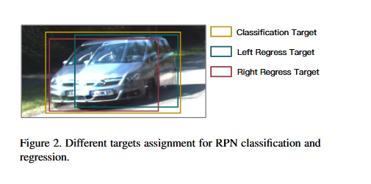

**2.2. Stereo Regression**

After stereo RPN, we have corresponding left-right proposal pairs. We apply RoI Align on the left and right feature maps respectively.The left and right RoI features are concatenated and fed into two sequential fully-connected layers (each followed by a ReLU layer) to extract semantic information.We use four sub-branches to predict object class, stereo bounding boxes, dimension, and viewpoint angle respectively.

*Note that the viewpoint angle is not equal to the object orientation.

We therefore regress the viewpoint angle defined as: **alpha = beta + theta** .

An example is illustrated in Fig. 3, where we use **theta** to denote the vehicle orientation respecting to the camera frame, and **beta** to denote the object azimuth respecting to the camera center.To avoid the discontinuity, the training targets are [sin(alpha) , cos(alpha)] pair instead of the raw angle value.

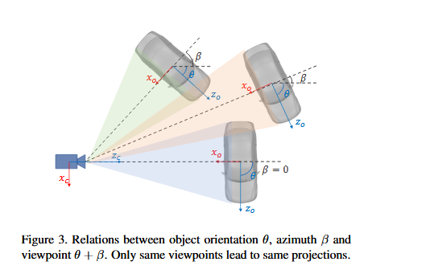

With stereo boxes and object dimension, the depth information can be recovered intuitively, and the vehicle orientation can also be solved by decoupling the relations between the viewpoint angle with the 3D position.

We consider a left-right RoI pair as foreground if the maximum IoU between the left RoI with left GT boxes is higher than 0.5, meanwhile the IoU between right RoI with the corresponding right GT box is also higher than 0.5. A left-right RoI pair is considered as background if the maximum IoU for either the left RoI or the right RoI lies in the [0.1, 0.5) interval. For foreground RoI pairs, we assign regression targets by calculating offsets between the left RoI with the left GT box, and offsets between the right RoI with the corresponding right GT box.

For dimension prediction, we simply regress the offset between the ground-truth dimension with a pre-set dimension prior.

**Keypoint Prediction**. Besides stereo boxes and viewpoint angle, we notice that the 3D box corner which projected in the box middle can provide more rigorous constraints to the 3D box estimation.we define four 3D semantic keypoints which indicate four corners at the bottom of the 3D bounding box. There is only one 3D semantic keypoint can be visibly projected to the box middle

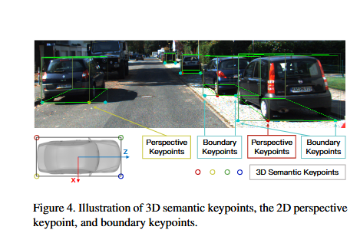

There is only one 3D semantic keypoint can be visibly projected to the box middle (instead of left or right edges). The perspective keypoint contributes to the 3D box estimation.We also predict two boundary keypoints which serve as simple alternatives to instance mask for regular-shaped objects. Only the region between two boundary keypoints belongs to the current object and will be used for the further dense alignment.

We predict the keypoint as proposed in Mask R-CNN.We feed the 14x14 RoI aligned feature maps to six sequential 256-d 3x3 convolution layers.A 2x2 deconvolution layer is used to upsample the output scale to 28x28. To relax the task, we sum the height channel in the 6x28x28 output to produce 6x28 prediction. As a result, each column in the RoI feature will be aggregated and contribute to the keypoint prediction.Note that only one of four 3D keypoints can be visibly projected to the 2D box middle, thereby softmax is applied to the first four channels 4x28 to a single location perspective keypoint type. For the left and right boundary keypoints, we apply softmax on the 1x28 outputs respectively.

**3- 3D Box Estimation**

In this section, we solve a coarse 3D bounding box by utilizing the sparse keypoint and 2D box information. States of the 3D bounding box can be represented by x = fx; y; z; g, which denotes the 3D center position and horizontal orientation respectively. Given the left-right 2D boxes, perspective keypoint, and regressed dimensions, the 3D box can be solved by minimizing the reprojection error of 2D boxes and the keypoint. As detailed in Fig. 5, we extract seven measurements from stereo boxes and perspective keypoints: z = { ul, vt, ur, vb, ul*, ur*, up }, which represent left, top, right, bottom edges of the left 2D box, left, right edges of the right 2D box, and the u coordinate of the perspective keypoint.Given the perspective keypoint, the correspondences between 3D box corners and 2D box edges can be inferred(Dotted lines). We have seven equations corresponding to seven measurements.

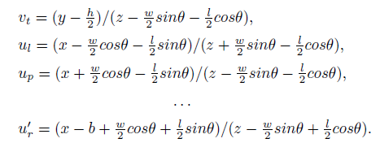

We use b to denote the baseline length of the stereo camera, and w, h, l

for regressed dimensions.

These multivariate equations are solved via Gauss-Newton method.

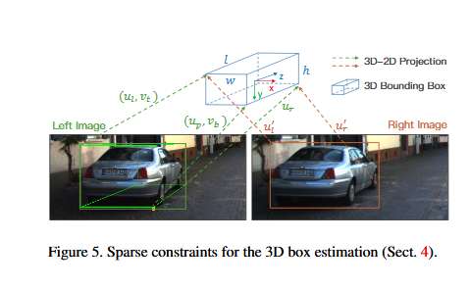

**4- Dense 3D Box Alignment**

-The left and right bounding boxes provide object-level disparity information such that we can solve the 3D bounding box roughly. However, the stereo boxes are regressed by aggregating the high-level information in a 7x7 RoI feature maps. The pixel-level information (e.g., corners, edges) contained in the original image is lost due to multiple convolution filters. To achieve sub-pixel matching accuracy, we retrieve the raw image to exploit the pixel-level high-resolution information. Only solve the disparity of the **3D bounding box center** while using the dense object patch, i.e., we use plenty of pixel measurements to solve one single variable.

-Treating the object as a regular-shaped cube, we know the depth relation between each pixel with the center of 3D bounding box solved from previous section.

-Consider the object RoI as a geometric-constraint entirety, Therefore this geometry-constraint dense alignment provides accurate depth estimation of object center.

**5- Results**

Average Recall (AR) and Average Precision (AP).

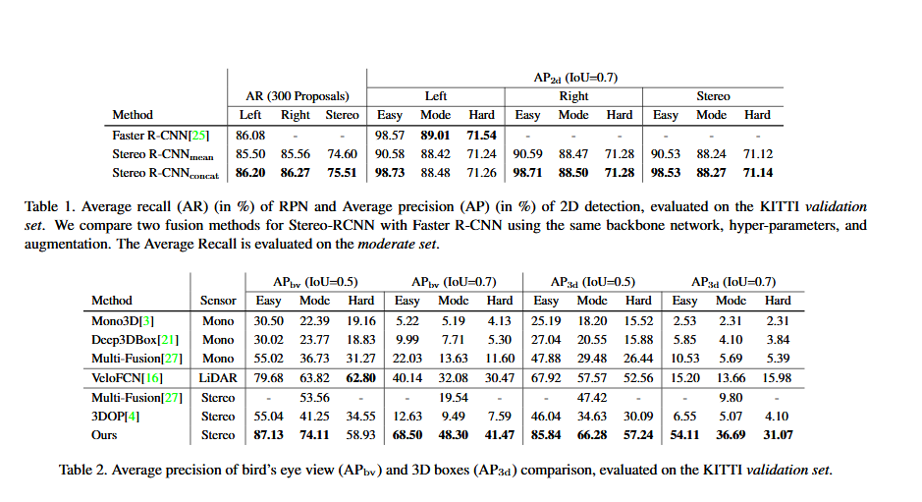

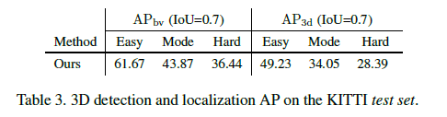

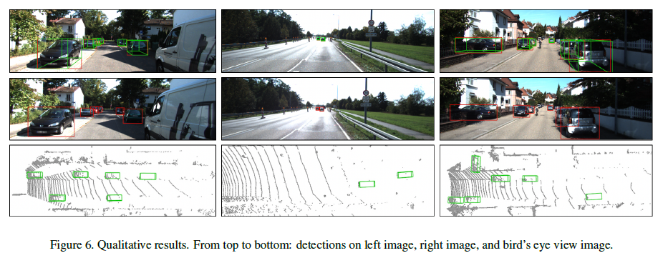

**Benefits of the Dense Alignment.**

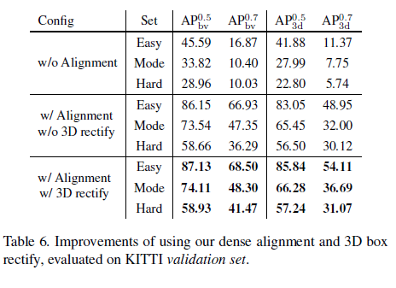

**Benefits of the Keypoint.**

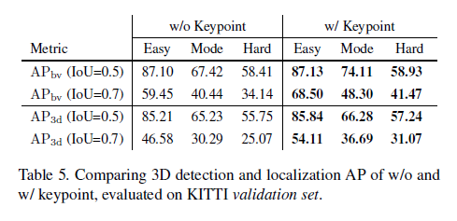

**6- Conclusion and Future Work**

-In this paper, A Stereo R-CNN based 3D object detection method in autonomous driving scenarios. Formulating the 3D object localization as a learning-aided geometry problem, approach takes the advantage of both semantic properties and dense constraints of objects. Without 3D supervision, we outperform all existing image based methods by large margins on 3D detection and 3D localization tasks, and even better than a baseline LiDAR method.

-This 3D object detection framework is flexible and practical where each module can be extended and further improved. For example, Stereo R-CNN can be extended for multiple object detection and tracking. We can replace the boundary keypoints with instance segmentation to provide more precise valid RoI selection. By learning the object shape, it can be further applied to general objects.

# **Our Results:**

These are sample of 3d object detection of our code 